**Year 10 Psychology**

**Reliability of Memory Research (Weighting 15%)**

**Part A**

|  |  |  |
| --- | --- | --- |
| **Name:** | | |
| **Class:** | **Due Date:** | **Teacher:** |

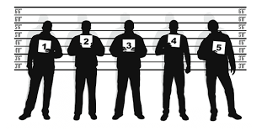

A psychologist known as Elizabeth Loftus, has been quite concerned with how eyewitness accounts can be distorted by subsequent misleading information. Statistics have shown that in the USA alone 69% of DNA exonerations have involved eyewitness misidentification, making it the leading contributing cause of these wrongful convictions.

1. Research Elizabeth Loftus and identify what her experiments were focussed on. (2 marks)

1. Research both of Elizabeth Loftus’s experiments and outline them below (including aim, method, and conclusion) (6 marks)

Experiment 1:

Experiment 2:

1. Research two additional memory experiments and provide their aim and method below (4 marks)

Experiment 1:

Experiment 2: